ANA INTERCONTINENTAL TOKYO, JAPAN

INTTERNSHIP REPORT

Submitted By
Abisek Purwe
BHM 8th semester
P.U. Registration No.: 068-2-2-03652-2019
South Asian School of Tourism and Hotel Management (SASTHM)

An internship report submitted to the Purbanchal University, Faculty of Management

In Partial Fulfillment of the requirements for the degree of Bachelors of
Hotel Management (BHM)
BHM-171: INTERNSHIP REPORT WRITING

June, 2024
Morang

DECLARATION
I, Abisek Purwe hereby declare that this internship report entitles, “ANA InterContinental Tokyo, Japan” has been submitted in partial fulfillment of BHM degree, the faculty of management, Purbanchal University is my original work carried out under the guidance of Dev Raj Shrestha sir, and has not been submitted anywhere for the award of any other degree or commercial purpose. In keeping with the ethical practice in reporting scientific information due acknowledgement have been made where ever the findings of other have been cited.

…………………………………….
Abisek Purwe
BHM VIII Semester
SASTHM
P.U. Reg. No.: 068-2-2-03652-2019

Date: ………………………………………… (A.D.)

Date: ………………………………………… (B.S.)

ACKNOWLEDGEMENT
This internship report has been entitled “ANA InterContinental Tokyo, Japan” in partial fulfillment for the compulsory requirement of the BHM 7^{7h} semester. It is prepared according to the format provided by the Faculty of Management, Purbanchal University. The purpose is to gain practical exposure in the specific field.
I’m indebted to Associate Prof. Dev Raj Shrestha for his precious time, stimulating suggestion and regular encouragement for the completion of the finalizing report in effective manner on time.
I am deeply thankful to Mr. Manuel Castro, my internship supervisor, for his guidance, support, and valuable insights throughout the internship period. His expertise and mentorship have been instrumental in shaping my understanding and professional growth in hospitality industry.
I am also thankful to ANA InterContinental Tokyo for providing me with the opportunity to intern at their esteemed organization. The exposure and experience gained during this internship have been invaluable in enhancing my skills and knowledge. I would like to extend my appreciation to the entire team at the hotel for their encouragement, cooperation, and assistance during my tenure. Their willingness to share knowledge and offer assistance whenever needed has been immensely helpful.
Furthermore, I am grateful to my academic institution, SASTHM, for incorporating this internship into my curriculum and for their continuous support throughout the process.
Thank you once again to everyone who has been a part of this enriching experience.
…………………………………….
Rabin Rajbanshi
BHM VIII Semester
SASTHM
P.U. Reg. No.: 068-2-2-03652-2019

Date: ………………………………………… (A.D.)
Date: ………………………………………… (B.S.)

ABBREVIATION

A.D. Anno Domini
ANA All Nippon Airways
ANT After Noon Tea
B.S. Bikram Sambat
BHM Bachelor of Hotel Management
e.g. Exempli Gratia
etc. Et Cetera
F&B Food and Beverage
IHG Intercontinental Hotel Group
LLC Limited Liability Company
Ltd. Limited
No. Number
Regd. No.: Registration Number

EXECUTIVE SUMMARY
The internship report entitled “ANA InterContinental Tokyo, Japan” is made for partial fulfillment for degree of Bachelor of Hotel Management (BHM), under the faculty of Management at Purbanchal University is prepared on the basis of six months exposure to the specific field/environment.
This research was conducted for six months from December 23, 2023 to June 24, 2024. The data was collected by primary method of data collection. The scope of this report is to identify and describe the analysis carried out, experiences gained and focuses on the achievement as an intern.
The overall findings of this intern report include overview of intern’s role and responsibilities during internship, experiences, new and improved skills, management, and many mores.
The research concluded that ANA InterContinental is a hybrid giant hotel evolved through the merge between All Nippon Airways and Intercontinental Hotel Group, delivering the overall hospitality facilities like Travel, Lodging, Fooding, etc.
The ANA InterContinental Tokyo is suggested to focus on its service quality and management. So that, the hotel operation becomes smooth and the standard is maintained. It is also suggested to focus on the employ’s quality life standard by providing proper work schedule, by avoiding- going for profit by disturbing employ’s quality life.

CHAPTER I

INTRODUCTION

Background of the study
Internship report entitled Food production department of " ANA InterContinental Tokyo" has been prepared in partial fulfillment of the Degree of the Bachelor of Hotel Management (BHM) Faculty of management, Purbanchal University.
The Bachelor of Hotel Management (BHM) is a 4 year, 8 semester program that teaches about the different facets of the hospitality industry. Conducting an internship is a integral part of the hotel management program. Students gain a great deal of experience in operational setting from different department. The course includes one year internship program at 7th and 8th semester with the option of converting the internship into a job. It also offer an employee an opportunity to bring new ideas and energy into the workplace. In an internship, aspirants are taught food and beverage preparation, housekeeping operations, front office operations, computer applications, business communication, accommodation operation, corporate finance, sales and marketing, public relations among others. The main aim of this internship is to develop a personality and capacity in student to handle challenging situations in the real business world. It also gives you an experience with technology, people and projects related to your career goals. BHM course also emphasizes developing and enhancing personal skills of an aspirant as a good personality is a must in the career path. Apart from this, the BHM course also educates on aspects such as hygiene, food safety as well as nutrition that is in tune with international level. The hotel industry is in high demand and has wide employment opportunities owing to its status as the secondary largest in the world.

1.2 STATEMENT OF THE PROBLEM
Le Petit Chef offers a diverse range of products including coffee, liquor and
Foods and from the kitchen perspective, variety of foods are prepared. The main aim of this kitchen is to maintain kitchen cleanliness, safety, sanitation, waste and food spoilage for the budget
friendly food due to which it faces several challenges in optimizing customer
satisfaction, and ensuring profitability.
This research aims to explore how the department can do better about customer
preference, streamline operations, and improve sales performance food categories. Therefore, this study seeks to examine how the kitchen invests in
customer retention and increase its profitability by maintaining efficiency in operation,
and optimal utilization of its resources.
To address these challenges, there is a need to implement a comprehensive
strategy that not only focuses on food handling and kitchen cleanliness but also ensures
sustainable growth in a competitive market. And in order to do so, it must introduce
training programs or modern equipment that can fulfill such criteria.
Additionally, targeting off-peak hours with promotions, special events, or unique menu
could help boost sales during slow periods and streamlining operations to reduce
inefficiencies, such as optimizing staffing schedules or improving inventory
management.

IMPORTANCE OF THE STUDY
This study is important as it highlights the operational effectiveness and guest satisfaction level at Le petit Chef, one of the key dining outlets of ANA InterContiental Tokyot. As foodproduction department plays a major role in the overall foodt experience, understanding the strengths and areas for improvement within this outlet is essential.
The study contributes to improving food quality by identifying key factors such as guest handling, order delivery time, staff coordination, and communication. These findings can help the management team implement strategies to enhance guest satisfaction, increase efficiency, and boost repeat business.
Furthermore, this study provides insights into the real-world challenges faced by the foodproduction team and highlights how teamwork, training, and food standards directly impact the success of a hospitality outlet. The findings can also be useful for future interns, hospitality students, and professionals looking to understand how premium food is maintained in a five-star environment.

OBJECTIVE
The overall objective of this report is to analyze the services of ANA InterContinental Tokyo.its specific objectives are as follows:
•To know about the number of cuisine served to the ANA InterContinental Tokyo.
•To know about the number of cuisine prefered by the guest.
• To know about the number of guest visiting the Hotel on the basis of nationality.
•To know about the number of repeated guest choosing the same outlet.

INTRODUCTION TO ANA INTERCONTINETAL TOKYO, JAPAN
ANA Hotel (全日空ホテルズ, Zen'nikkū Hoteruzu) is a Japanese hotel chain established in 1973 by All Nippon Airways (ANA). In October 2006, ANA sold majority ownership of ANA Hotels to the InterContinental Hotels Group (IHG), which is now the primary shareholder. The managed properties of ANA Hotels are marketed under the ANA InterContinental, ANA Crowne Plaza, ANA Hotels and ANA Holiday Inn brands (Wikipedia.com, 2024 June 30).
ANA InterContinental Tokyo, a 37-storey hotel, provides a total of 844 guest rooms, 11 restaurants and bars, over 20 banquet rooms of various sizes. Situated in the heart of Tokyo, the hotel is within walking distance from Akasaka, Roppongi and Kasumigaseki districts. The Central Government office, Consulate-General of various countries, leading domestic and foreign companies and other key corporations are also concentrated in the area.
Club InterContinental Lounge located on level 35 of the hotel offers unparalleled level of service and breath-taking views of Tokyo's skyline and Mount Fuji. This is undoubtedly the largest and most luxurious Club Lounge in the island of Japan. Club InterContinental offers the right level of luxury and space for discerning business and leisure travelers. The lounge is divided into six different zones, including Reception, Library, Relaxation, Dining, Bar and Meeting. Guests can enjoy an impressive line-up of facilities and services tailor-made to suit their needs. Set against a breathtaking backdrop of The Imperial Palace, Parliament House, Mount Fuji and Tokyo Bay, the Hotel offers guests from across the world a whole new living space equipped with both superb relaxation and business facilities (ANA InterContinental Tokyo, 2024 June 30).
ANA Intercontinental Tokyo is a luxury 5-star hotel located in the heart of Tokyo. this luxury hotel has a vibrance and elegance that reflects the city itself. It has twelve very individual dining restaurants, bar and lounges. One of the city’s most important gathering places, the twenty-two unique spaces at ANA InterContinental Tokyo include the famous Prominence Ballroom, a range of mid-size event suites, light flooded skyhigh event spaces on the 37th floor and an independent break-out and small meeting Centre. The Hotel mirrors the rich diversity of the city- Tokyo.
ANA InterContinental Tokyo is a luxury hotel with vibrance and elegance that reflects the city itself. The buzzing energy of the lobby mirrors our famous city streets, while our 12 on-site restaurants deliver exceptional world-class dining experiences for which Tokyo is famous. Step into sophistication in our Club InterContinental for a reprieve from the hustle and bustle outside, and enjoy a calming, comfortable stay in one of our 884 guest rooms (anaintercontinental-tokyo.jp, 2025 november 16)

Methodology of Data Presentation
The methodology of data presentation explains how secondary data from hotel records and reports will be organized and analyzed to meet the study objectives. The data focuses on guest cuisine preferences, repeat visits to F&B outlets, and staff nationality distribution at ANA InterContinental Tokyo.
Data will be presented using tables, percentages, and charts for clarity. Tables will summarize counts such as guest preferences, repeat visits across the 8 F&B outlets, and staff distribution by nationality (Nepalese, Indian, Filipino, Others). Pie charts and tables will visually display trends and comparisons. Percentages and frequency distributions will highlight patterns, while descriptive analysis will interpret the results.

STUDY DESIGN
This study attempts to analyze the Food Production department of ANA InterContinental Tokyo.

SOURCE OF INFORMATION
In this study, primary and secondary data have been used to fulfill the objective of the research.

PRESENTATION AND ANALYSIS OF DATA
Collected data are organized into simple tables with the distribution frequency data and are tabulated in order of research objectives. The data are then analyzed systematically. For this, statistics was used such as percentage.

ORGANIZATION OF THE STUDY
The entire internship report has been organized into three chapters, each focusing on different aspects of the study. They are as follows:
Chapter I: INTRODUCTION TO THE TOPIC
This chapter provides an overview of the internship report. It includes the background of the study, statement of the problem, objectives of the study, importance of the study, introduction to the hotel.
Chapter II: PRESENTATION AND ANALYSIS OF DATA
This chapter presents the data collected during my internship at ANA InterContinental Tokyo. The analysis is carried out in line with the objectives of the study.
Chapter III: RECOMMENDATIONS AND CONCLUSION
This chapter highlights the summary and conclusions derived from the internship experience. It includes a reflection on the skills and knowledge gained, a comparison between expected and actual learning, key achievements, personal observations, recommendations, and a final conclusion.
REFERENCES AND APPENDIX
At the end of the report, the References section lists the books, websites, and other sources used. The Appendix includes questionnaires, photos, and supporting materials related to ANA InterContinental Tokyo and the internship study.

CHAPTER ll

PRESENTATION AND ANALYSIS OF DATA

2.1 Data Presentation
This chapter focuses on presentation and analysis of data within the scope of research objective followed by interpretation and respective conclusions.

2.2 To know about the number of cuisine served to the ANA InterContiental Tokyo.
The objective of this section is to find out how many types of cuisines are served at ANA InterContinental Tokyo. The study focuses on three main categories of food offered by the hotel: Japanese cuisine, Asian cuisine, and International cuisine. By identifying the number of outlets under each category, the report aims to understand the hotel’s variety of dining options and how it meets the needs of different guests
Table 2.2 Number of cuisine served
Cuisine | Number of guests | Percentages%
Japanese | 190 | 40%
Asian | 120 | 25%
International /continental | 165 | 35%
Total | 475 | 100%
Source : Internal Record at ANA InterContiental Tokyo

Table 2.2 is shown in the Figure 2.2
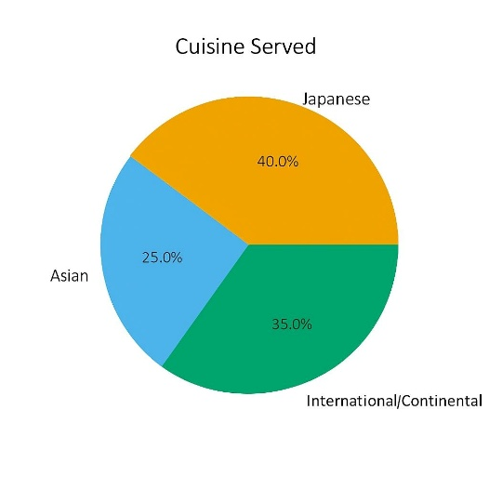
Figure 2.2 The number of cuisine served
Table 2.1 and figure 2.1 shown the number of cuisine served to the ANA InterContiental tokyo the specialy cuisine served are japanese ,Asian and international or contiental which mix up almost all of the cuisine available at he hotel boath the table and figure highlight the exact percentage of every cuisine served at the hotel japanese cuisine is served 40%,asian cuisine served 25%,where as international or contiental cuisine is served 35% the overall results shown that japanese cuisine is served the most ana Asian cuisine the served the least.

2..3 To know about the number of cuisine preferred by the guest.
The objective of this section is to find out which cuisine is most preferred by the guests. By collecting information from guests through surveys or observations, the study aims to understand whether they prefer Japanese, Asian, or International cuisine. Knowing the guests’ preferences helps the hotel identify which type of food is more popular and ensures that the menu and restaurant services are planned according to what guests like the most. This information also supports better decision-making in improving guest satisfaction and enhancing the overall dining experience

Table 2.3 Number of cuisine preferred
Cuisine | Number of cuisine preferred | Percentages%
Japanese | 190 | 40%
Asian | 120 | 25%
International /continental | 165 | 35%
Total | 475 | 100%
Source : Internal Record at ANA InterContiental Tokyo.
Table 2.3 is shown in the figure 2.3
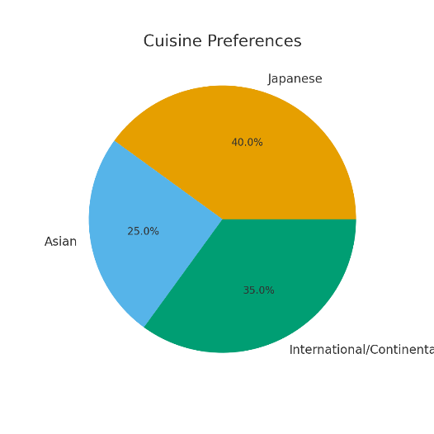
Figure 2.3 The number of cuisine preferred
Table 2.3 and figure 2.3 shown the number of cuisine preferred by the guest the specialy cuisine preferred are japanese ,Asian and international or contiental which mix up almost all of the cuisine available at he hotel boath the table and figure highlight the exact percentage of every cuisine preferred at the hotel japanese cuisine is preferred 40%,asian cuisine preferred 25%,where as international or contiental cuisine is preferred 35% the overall results shown that japanese cuisine is preferred the most ana Asian cuisine the preferred the least.

2.4 To know about the number of guest visiting hotel on the basis of nationality.
The objective of this section is to find out the number of guests visiting the hotel based on their nationality and gender. By collecting and organizing guest information, the study aims to identify how many visitors come from different countries and how many are male or female. Understanding this helps the hotel analyze its guest demographics, recognize its major markets, and provide services that meet the needs of different groups of guests. It also supports future planning in marketing, staffing, and improving overall guest satisfaction.

Table 2.4 Number of guest visiting
Nationality | Number of guest | Percentage (%)
Japanese | 86 | 20%
Indian | 101 | 28%
Filipino | 81 | 18%
Nepali | 76 | 15%
Spanish | 66 | 10%
myanmar | 65 | 9%
Total | 475 | 100%
Source: Internal Record at ANA InterContiental Tokyo.

Table 2.4 is shown in the figure

The table 2.4 and figure 2.4 shown the number of guest visiting according to the nationality out of 475(100%) ,101(28%) guest of total are from indian who are considered as most visited guest in ANA intercontiental tokyo followed by japanese 86(20%),by 81(18%) filipino by nepali 76(15%) ,by spanish 66(10%),and myanmar 15(8%) this shown indian guest are the most visiting hotel among other nationality mention above.

2.5 To know about the number of repeated guest choosing the same outlet.
The objective of this section is to find out how many repeat guests choose the same outlet during their visits. This involves identifying guests who return to the hotel and prefer to dine at the same restaurant or outlet each time. Understanding repeat guest behavior helps the hotel evaluate guest loyalty, measure satisfaction with specific outlets, and identify which outlets are performing well. This information also supports planning to improve service quality and maintain strong relationships with loyal guests.

2.5 Number of repeated guest
Outlets | No. of Repeat Guest per Week | Percentage (%)
Le petit chef | 95 | 20%
Cascade cafe | 82 | 16%
Steakhouse | 68 | 14%
Mixx bar and lounge | 55 | 12%
Akasaka | 50 | 11%
Brewers | 45 | 10%
Da vinci | 42 | 9%
Atrium | 38 | 8%
Total | 475 | 100%
Source : Internal Record at ANA InterContiental Tokyo.

Table 2.5 is shown in the figure

The table 2.5 and figure 2.5 shown the repeated guest preferred same outlet at ANA InterContiental Tokyo the majority of repeated guest preferred le petit chef 95(20%),followed by cascade cafe 82(16%) and steak house 68(14%), outlets such as mixx bar and lounge 55(12%),Akasaka 50(11%) and brewars 45(10%) also attracted a significant share of repeat guest, meanwhile Da Vinci 42(9%) and Atrium 38(8%) had comparatively fewer repeated gues.
This indicates that outlets with strong menu offering And memorable dining experience (such as le petit chef and cascade cafe) are more suscessfull in building guest loyalty ,while other outlets may need to focus on enhancing service quality and guest engagement to improve repeat visitation.

CHAPTER III

RECOMMENDATION AND CONCLUSION

3.1 RECOMMENDATION
Hospitality is a field that covers a vast area with limitless possibilities. The one year internship has provided valuable insights into the operations and management of the hospitality industry, particularly within the Foodproduction Department. Based on the observations and experience during the internship, the following recommendations are proposed to improve the department’s performance and service quality.
Specific Recommendations:
- The Foodproduction Department should add more cuisines to cater to guests from different nationalities.
- Special offers and promotional activities should be introduced to ensure smooth operations and attract more guests.
- The variety of food should be increased to improve foodquality and guest satisfaction.
- Promotional activities should be carried out on different platforms, especially during off-season periods, to attract more guests.
- Staff should receive training regarding product knowledge, as some employees may not be aware of hotel discounts or offers.
- Regular training programs should be conducted for new staff and trainees to familiarize them with hotel standards and operational procedures.
General Recommendations:
- Customer service should be enhanced through continuous training in hospitality etiquette, communication, and problem-solving skills.
- Facilities, including dining areas and recreational spaces, should be regularly upgraded and maintained to ensure guest comfort.
- Modern technology, such as digital feedback systems, mobile service requests, and online booking platforms, should be incorporated to improve efficiency and convenience.
- Sustainable practices, such as energy conservation and eco-friendly initiatives, should be implemented to strengthen the hotel’s brand image.
- Marketing strategies and loyalty programs should be strengthened to attract new guests and retain repeat visitors, supporting long-term growth.

3.2 CONCLUSION
During the one-year internship at ANA InterContiental Tokyo, working in the Foodproduction Department, I gained extensive practical experience and a deeper understanding of the hospitality industry. The experience allowed me to observe and participate in the day-to-day operations of a five-star hotel, kitchen management, menu planning, and event coordination. The internship also exposed me to the organizational structure of a luxury hotel, staff coordination, and the challenges involved in maintaining high standards of food consistently. I learned about inventory management, handling food and its wastage, and maintaining kitchen safety and sanitation activities, which improved my decision-making skills. Additionally, I was involved in training programs for new staff and gained insights into professional standards and operational protocols. This one-year experience not only strengthened my technical and interpersonal skills but also shaped my professional perspective, allowing me to understand the strategic importance of efficient operations, team coordination, and customer satisfaction in the success of a hospitality establishment. Overall, this internship was a transformative learning experience, providing both practical knowledge and personal growth, and it has prepared me for a successful career in the hotel industry.

3.3 FINDINGS
The analysis of the Foodproduction Department during the one-year internship at ANA InterContiental Tokyo revealed several key findings regarding operational efficiency, staff management, and guest satisfaction. It was observed that the hotel maintains a high standard of food quality, with staff demonstrating professionalism and attentiveness in handling guest requests. Breakfast and main dining outlets were the most visited, indicating peak operational hours that require optimal staff allocation. The study also highlighted the diverse preferences of guests, emphasizing the need for a wider variety of cuisines and beverages to cater to different nationalities. Staff training was found to be essential, as some employees were not fully aware of promotional offers or hotel policies, affecting service delivery. Additionally, promotional activities and marketing strategies were not consistently implemented during off-peak seasons, which limited guest engagement and repeat visits. The feedback mechanisms in place were effective but could be enhanced through digital tools to monitor guest satisfaction more efficiently. Overall, the findings suggest that while the hotel excels in maintaining quality service and operational standards, there are opportunities for improvement in staff training, menu variety, promotional activities, and the use of technology to further enhance the guest experience.

REFERENCES
BOOK REFERENCES

Bennett, S. (2011). History of hospitality industry. London: Butterworth-Heinemann.

Cousins, J., Foskett, D., Graham, D., & Hollier, A. (2019). Food and beverage management, 5/e. Oxford: Goodfellow publishers.

Kavanaugh, R.R., & Ninemeier, J. D. (1995). Hospitality supervision, 2/e. Michigan:
Educational Institute.

Lillicrap, D. R., & Cousins, J. (2012). Food and beverage service, 8/e. London: Hodder Education.

Ninemeier, J. D. (2013). Planning and control for food and beverage operations, 8/e. Michigan: American Hotel & Lodging Educational Institute.

Raghubalan, G. (2007). Hotel housekeeping operations and management. New Delhi:
Oxford University Press.

Sharma, P. D. (2012). Hospitality management impact of internship on hotel operation.
Kokkola-Pietarsaari: Unit for Technology and Business.

Tewari, J. R. (2009). Hotel front office operations and management. New Delhi: Radha Press; New York: Oxford University Press.

WEB REFERENCES

< http://anaintercontinental-tokyo.jp.com> (June 16, 2024)
< http://britannica.com> (June 01, 2024)
< http://forbesadvisor> (June 19, 2024)
< http://hospitalityinsights.ehl.edu> (June 15, 2024)
< http://luxurylifestylemagazine.com> (June 10, 2024)
< http://linkedin.com/nadir> (June 26, 2024)
< http://openai.com> (June 17, 2024)
< http://wikipedia.com> (June 30, 2024)

APPENDIX I
PHOTOGRAPHS OF ANA INTERCONTINENTAL TOKYO, JAPAN

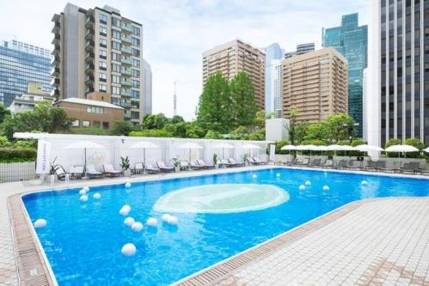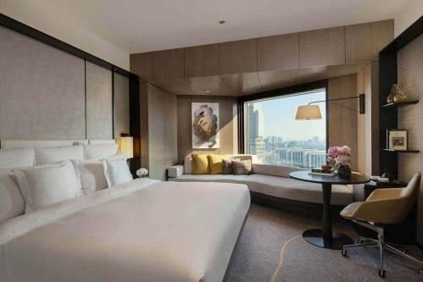
Photo 1: Swimming Pool Photo 2: “Kintsugi” Premiere Room

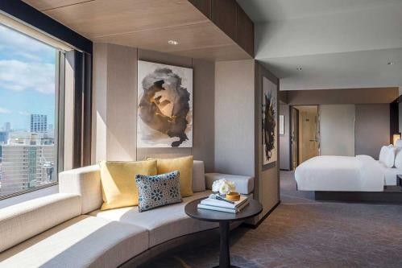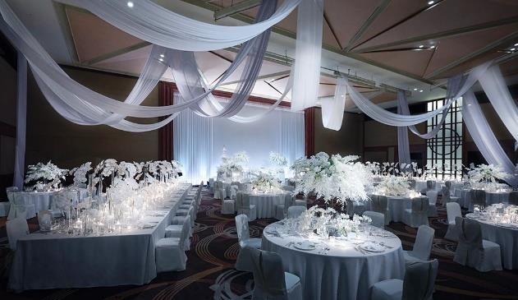

Photo 3: Suite Room Photo 4: Chapel Brilliant

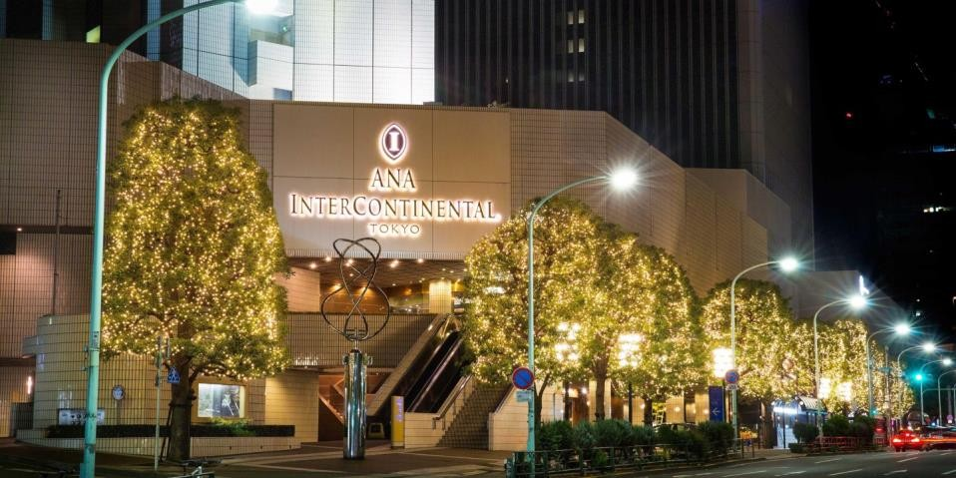
Photo 5: Front view of ANA InterContinental Tokyo

